Beside the Group Name, "######", is the Group's General Service Office Registered Number which identifies the Group within

the A.A. Service Structure. The GSO Number should be used by the Group Secretary/Treasurer on all contribution checks to GSO, VAC and District #16.

Information may be obtained by writing
the
DISTRICT 16 INTERGROUP
P.O. BOX 1294, HOPEWELL, VA. 23860

OR CALLING (804) 452-1959

WWW.VASOUTHCENTRALAA.ORG
District 16
P.O.Box 2328
Petersburg, VA 23803

VAC Treasurer
P.O. BOX 35445
N Chesterfield, VA 23235
As of JANUARY 2017
www.aavirginia.org

Alcoholics Anonymous
P.O. Box 459, Grand Central Station
New York, NY 10163
www.AA.org

If you have been affected by a friend or family members drinking contact

Serenity Prayer

God grant me the serenity to accept the things I cannot change, the courage to change
the things I can,
and the wisdom
to know the

difference.

ALANON

320-634-6734

NAMES and

PHONE NUMBERS

The Twelve Steps
of Alcoholics Anonymous

- We admitted we were powerless over alcohol, that our lives had become unmanageable.

- Came to believe that a power greater than ourselves could restore us to sanity.
- Made a decision to turn our will and our lives over to the care of God as we understood him.
- Made a searching and fearless moral inventory of ourselves,
- Admitted to God, to ourselves and to another human being the exact nature of our wrongs.
- Were entirely ready to have God remove all these defects of character.
- Humbly asked him to remove our shortcomings.
- Made a list of all persons we had harmed and became willing to make amends to them all.

- Made direct amends to such people wherever possible, except when to do so would injure them or others.

- Continued to take personal inventory and when we were wrong promptly admitted it.
- Sought through prayer and meditation to improve our conscious contact with God as we understood Him, praying only for knowledge of His will for us and the power to carry that out.
- Having had a spiritual awakening as the result of these steps, we tried to carry this message to alcoholics and practice these principles in all our affairs.

District 16 Intergroup meets at 6:45PM the 2nd Wed. of every month AND District 16 District meeting is 10:30AM the 2nd Sat. of every month. Both meet at the Tri-City Club/St Paul Episcopal Church-110 N. Union St.(enter from Market St)

Petersburg, VA

The South Central Virginia Phone Watch is manned on a volunteer basis by recovering members of ALCOHOLICS ANONYMOUS. It's PRIMARY PURPOSE is to answer the call for help from the alcoholic who still suffers. It is a 24 HOUR HOTLINE. The phone watch volunteer can provide information and directions to all meetings in the Tri-City area. He or she will be able to answer most of your questions concerning A.A.

RICHMOND PHONEWATCH

(804) 355-1212

The Twelve Traditions
of Alcoholics Anonymous

- Our common welfare should come first; personal recovery depends upon AA unity.
- For our group purpose there is but one ultimate
authority-a loving God as He may express himself in our group conscience. Our leaders are but trusted servants; they do not govern.

- The only requirement for AA membership is a desire to stop drinking.
- Each group should be autonomous except in matters affecting other groups or AA as a whole.
- Each group has but one primary purpose-to carry its message to the alcoholic who still suffers.
- An AA group ought never endorse, finance, or lend the AA name to any related facility or outside enterprise; lest problems of money, property and prestige divert us from our primary purpose.

- Every AA group ought to be fully self-supporting, declining outside contributions.
- Alcoholics Anonymous should remain forever nonprofessional, but our service centers may employ special workers.

- AA, as such, ought never be organized; but we may create service boards or committees directly responsible to those they serve.

- Alcoholics Anonymous has no opinion on outside issues; hence the AA name ought never be drawn into public controversy.

- Our public relations policy is based on attraction rather than promotion; we need always maintain personal anonymity at the level of press, radio and films.

- Anonymity is the spiritual foundation of all our Traditions, ever reminding us to place principles before personalities.

"....When anyone, anywhere,
reaches out for help, I want the hand of A.A. always to be there, and for that: I am responsible."
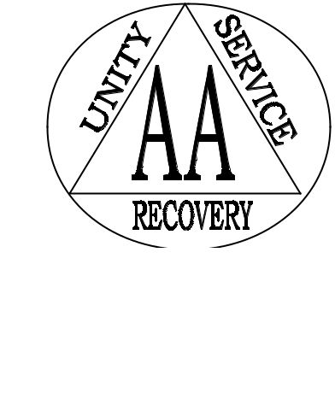

MEETING DIRECTORY
**All MEETING LOCATIONS AND TIMES ARE SUBJECT TO CHANGE. If you are attending a meeting for the 1st time, please call the hotline to confirm the information on this schedule.

(804) 452-1959

WWW.VASOUTHCENTRALAA.OR

DISTRICT 16
SOUTH CENTRAL
VIRGINIA June 2018

June

2018

A.A.
Preamble

Alcoholics Anonymous is a fellowship of
men and women who share their experience,
strength and hope with each other that they
may solve their common problem and help
others to recover from
alcoholism.

The only requirement for membership is a desire to stop drinking. There are no dues or fees for A.A. membership; we are self-supporting through our own contributions.

- is not allied with any sect, denomination, politics, organization or institution; does not wish to engage in any controversy; neither endorses nor opposes any causes.
Our primary purpose is to stay sober and help other alcoholics
to achieve sobriety.

Above copyright by A.A.

Grapevine, Inc.; reprinted with permission

Alcoholics Anonymous
P.O. Box 459, Grand Central Station

New York, NY 10163

