DISTRICT 16 ESTABLISHED 1997 SPRING 2018

SOBER VOICES

This is your newsletter. Would like to have short articles (about 300-600 words) written by AA members telling of their experiences with the 12 Steps and Traditions. You may also send any announcements for your group to put in. The newsletter will be sent out to the district website four times a year. There will also be printed copies available for each home group.

If you have any information for the website, please send it to this email address:

website@vasouthcentralaa.org

!

Five small words that can change your life! Think of the very small phrases in your life that are life altering….I love you, Will you marry me?, You’re pregnant, You have cancer,
I want a divorce….and the list goes on. But these five words can save our lives. They

can bring us a whole new way of life. A life lived soberly and only for one day at a time!

The Circle and the Triangle

"The circle stands for the whole world of A.A., and the triangle stands for A.A.'s Three Legacies of Recovery, Unity, and Service. Within our wonderful new world, we have found freedom from our fatal obsession. That we have chosen this particular symbol is perhaps no accident. The priests and seers of antiquity regarded the circle enclosing the triangle as a means of warding off spirits of evil, and A.A.'s circle and triangle of Recovery, Unity, and Service has certainly meant all of that to us and much more." (Bill W.,
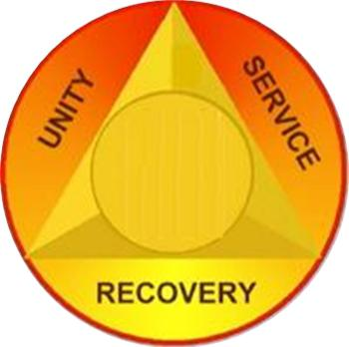

DISTRICT 16 ESTABLISHED 1997 SPRING 2018

Alcoholics Anonymous Comes of Age, Bill W.’s 1955 speech)

The symbol of the circle and triangle is an ancient spiritual symbol meaning mind, body, and spirit together as one.

In AA, this symbol represents the three parts of our program (recovery, unity, service) which are the solutions to the three-part disease of alcoholism (physical, mental and spiritual). The circle surrounding the triangle represents Alcoholics Anonymous as a whole. The equilateral triangle is the strongest construction structure known to us. Because all three sides are equal, the triangle represents the balance required among all 36 principles in order for us to stay sober.

So the solution to our alcoholism is found in the Three Legacies (Recovery, Unity and Service) passed down to us by our co-founders, Dr. Bob, Bill W. and the first pioneers of AA, Each legacy has twelve guiding spiritual principles. A total of 36 guiding principles. Each of spiritual principles are contained in the Big Book of Alcoholics Anonymous (Recovery, Unity, Service), the Twelve and Twelve (Recovery and Unity), and the General Service Manual (Service).

The following is an explanation of each of the Legacies and its Spiritual Principles:

Recovery/Mind/The Individual (Mental Obsession)

- The Set of Twelve Spiritual Principles (the 12 Steps), used to recover from alcoholism, are found in the first part of the Big Book, ending on page 164 and in the Twelve Steps and Twelve Traditions.

- The 12 Steps are known as Recovery and it is the entire foundation of our program. Thus it is the bottom of the triangle, holding up Unity and Service. The physical compulsion and the mental obsession are removed when we have completed the 12 Steps. Then comes the promise, we have recovered from a “seemingly hopeless state of mind and body”. Unity and Service cannot be a part of our lives unless we are practicing these principles in all our affairs. We cannot give away what we do not have ourselves.

- So in order to determine whether we are in fit spiritual condition, we do a nightly inventory as part of Step 11 (BB 86:1):
"When we retire at night, we constructively review our day. Were we resentful, selfish, dishonest or afraid? Do we owe an apology? Have we kept something to ourselves which should be discussed with another person at once? Were we kind and loving toward all? What could we have done better? Were we thinking of ourselves most of the time? Or were we thinking of what we could do for others, of what we could pack into the stream of life? But we must be careful not to drift into worry, remorse or morbid reflection, for that would diminish our usefulness to others. After making our review we ask God’s forgiveness and inquire what corrective measures should be taken.”

DISTRICT 16 ESTABLISHED 1997 SPRING 2018

Unity/Body/The AA Group (Physical)

- The 12 spiritual principles used within the fellowship are the 12 Traditions found in the Twelve Steps and Twelve Traditions and the Appendix of the Big Book (Fourth Edition).

- The second Legacy, Unity (Body) suggests we join a home group and participate in the meetings. In early sobriety, meetings and fellowship with recovered alcoholics can help to keep a newcomer sober until they have completed their steps and found a higher power. The fellowship of AA is the group members and is fondly referred to as “the meeting before the meeting, the AA meeting, and the meeting after the meeting.”

More importantly, however, the group and its members are responsible for making sure that the door to the meeting is open and there for the newcomer.

- Do I have a group that I am committed to and involved with? When I am participating in AA and Group Conscious meetings, do I follow the 12 Traditions?

I am responsible. When anyone, anywhere reaches out for help, I want the hand of AA to be there. And for that: I am responsible."

Service/Spirituality/The AA Organization (Spiritual Malady)

- Service in AA is based in the 12 spiritual principles known as the 12 Concepts, which are found in the General Service Manual and the Appendix of the Big Book (Fourth Edition).

- “12. Having had a spiritual awakening as the result of these steps, we tried to carry the message to another alcoholic and to practice these principles in all our affairs.” (BB 60:1) “PRACTICAL EXPERIENCE shows that nothing so much insures immunity from drinking than intense work with other alcoholics. It works when other activities fail. This is our TWELFTH SUGGESTION: Carry this message to other alcoholics!” (BB 89:1)

- The current service structure put in place by Bill W. And Dr. Bob allow recovered alcoholics to have resources at their disposal in order to help another alcoholic achieve sobriety.

- Am I working with other alcoholics taking them through the twelve steps? Am I practicing all of the spiritual principles inside and outside AA? Am I restless, irritable or discontent? If AA is the 12 Steps, the fellowship, and working with others, where am I with my program?

________________________________________________________________

On January 22, 2018, the Roundtable Group of Alcoholics Anonymous hosted a breakfast and speaker meeting in honor of their 40 years of service and outreach. We

DISTRICT 16 ESTABLISHED 1997 SPRING 2018

had an attendance of 50 some people at 9 0’clock on a cold Monday morning. Many homegroup members arrived by 8 am to help set up and organize and get the coffee going. This event was well planned, and there was so much food even the latest latecomers were amply fed. Plenty of great food, cooked and prepared by willing homegroup members and other generous individuals, plenty of coffee and juice, breakfast casseroles and desserts were enjoyed by all. We had a special cake as well, to honor a homegroup member who just celebrated his anniversary the previous week. At 10 o’clock our speaker, Myles M. spoke about his long-standing membership in District 16 and shared his experience, strength and hope with a well fed crowd of friends of Bill W., entertaining us with his humor, his personal experiences, and his obvious love of A.A. and our fellowship. Chips were given out for a number of anniversaries and the most important chip of all, the white one, was picked up amid much applause. This kind of enthusiasm and welcoming spirit has made the Roundtable what it is today: a safe, accepting, welcoming, and comforting place to be on 4 mornings a week for the last 40 years. Thank you to everyone who attended, helped, organized and contributed to a wonderful celebration of a wonderful Homegroup. Forgive me if I am a little biased.

A proud and grateful homegroup member of the Roundtable Group of Alcoholics Anonymous,

Lori C. DCM, District 16

____________________________________________________________

_

20 COMMON THINGS PEOPLE REALIZE WHEN THEY QUIT DRINKING

ALCOHOL
1.

The first major thing people see is a dramatic improvement in overall physical health. This commonly includes significant weight loss, improved digestion, greater energy and less fatigue, clearer skin, and they do not wake up with even mild hangovers, headaches or nausea.

2.

Improvements in mental health include decreased overall anxiety, improvements in depression, much higher levels of mental clarity, improved memory, better concentration, increased sense of connection, decreased levels of stress, higher self-esteem, greater motivation and a more positive outlook on life in general.

3.

Sleep dramatically improves. They find it much easier to fall asleep, they sleep much better throughout the night, and they feel much more rested upon waking.

4.

They commonly see big changes in their attitude towards other people, noticing that it tends to be easier to see things from the perspective of others as they feel less self-absorbed. They find it much easier to be empathetic towards others.

5.

Quitting drinking typically saves a great deal of money.

DISTRICT 16 ESTABLISHED 1997 SPRING 2018

6.

They save a great deal of time as they get their evenings, night-time, and mornings back. They frequently embark in new endeavors or try new activities which were impossible to do with an alcoholic lifestyle.

7.

They realize that they don’t actually need to drink to have fun and enjoy themselves at parties and social gatherings, thus exposing the great cultural lie that alcohol equals a good time. For many, they discover that alcohol actually strains social relationships rather than strengthening them.

8.

They begin to see themselves for who they really are, no longer using alcohol as a mask behind which to hide. This can be both enlightening and startling as they are forced to accept both the good and the bad aspects of the self. They must then choose how to confront the emotional realities of their life. Something that is all but impossible with regular consumption of alcohol.

9.

They realize that alcohol tends to make personal problems worse.

10.

People find they have fewer regrets when living alcohol free. Not only do they no longer do stupid, risky and troublesome things, but they also are more available to experience more from life.

11.

Quitting is both very difficult and very easy. The first stretch when they stop drinking is the most challenging, as the cravings for booze must be reckoned with, yet once they’ve experienced sobriety, they find it is much easier than they had imagined to stay sober, even when hanging out with drunk people.

12.

For some reason it really makes drinkers uncomfortable to be around someone who is abstaining. They realize that people who drink are incredibly judgmental towards non-drinkers, and will try anything to get a sober person to join the party with a drink. They will even make fun of you or put you down.

13.

They notice that many people are just assholes when they drink. This is not always easy to see when partaking in booze with everyone else, but with the clarity of sobriety, many find that the quick-witted social rock stars who seem so impressive at the bar are just really attention seeking jerks.

14.

They realize that booze fueled conversations are actually boring, ego-driven and quite superficial, as well as highly prone to aggressiveness, bickering, fighting and ill sentiments.

15.

They realize that people can be just as toxic as substances, and that many relationships are not able to survive without the crutch of booze. They tend to learn a great deal about who their true friends really are.

DISTRICT 16 ESTABLISHED 1997 SPRING 2018

16.

They begin to understand that alcoholism is in large part an environmental disorder, meaning that it is just as easy to not drink once a reasoned change has been made to their environment, who they spend time with, who they work with, and what they do in their free time.

17.

Alcohol is the least fulfilling and least interesting buzz available, when compared to many other mind-altering and mind-expanding substances people take to alter consciousness.

18.

They find it easier to make healthier choices in general, choosing better foods, drinking more water, taking more exercise, and purposefully sleeping better.

19.

They find that not drinking allows them to experience a greater level of spiritual awareness and consciousness in their everyday lives.

20.

They find that a return to drinking alcohol is often immediately gratifying with one or two drinks, but that shortly after consuming even a small amount of alcohol they feel crappy, lethargic, spaced out, dizzy and off.

Ruth B.

Final Thoughts

Not drinking alcohol can give you a serious edge in a society where most everyone else is boozing it up on a regular basis. The zeitgeist of alcohol is that it makes life more fun, but the reality is that it is a massive industry pushed onto the public which has created a culture of self-destructive behavior.

Changing your personal habits to improve your health, mental clarity and spiritual awareness is challenging, but doing so is perhaps the single most critical facet of personal development. Many people find that abstaining from booze makes this process much easier.

Small Beginning Group

Has moved to

1228 South West Street

Salvation Army Command Center

Petersburg, Virginia

They still meet Monday and Friday 7:30-8:30 a.m.

DISTRICT 16 ESTABLISHED 1997 SPRING 2018

Came to Believe

Science offers nothing in the way of comfort for the troubled mind, and more importantly for a drunk offers nothing in the way of a solution.

Bill Wilson wrote that he had more or less believed in "the strange proposition that this universe originated in a cipher and aimlessly rushes nowhere".( AA pg 10) A negative expression of a true thing, so far as any scienctist has determined. He disparaged science, his failed religion, as he struggled to provide an explanation for his new faith derived from mystical, probably drug induced experience. The usual rookie mistake. The only alternative he could imagine was that he had finally lost his mind. And Douglas Adams wasn't around yet to offer his alternative proposal.For many of us with the biological gift of alcoholism, the solution is readymade. Drinking. For as long as it works, or there remains any hope of it working.

The great obsession of every abnormal drinker is that he will one day control and enjoy his drinking. AA, pg 30

There is always, and based in solid personal experience, a real belief in that solution. Unless and until that wonderful religion, that terrible belief, is smashed, there is no possibility of recovery. As the losses of matter and mind accumulate- as everything else in life loses its flavor or is physically gone- the need for drinking increases, until there is only drinking which offers any relief from the purgatory of life experience without it.

And then the belief in drinking fails, because drinking fails. Belief in himself fails, because he has failed.

This is Fred Nietzsche's self- fulfilling prophecy-

Independence is for the very few; it is the privilege of the strong. And whoever attempts it even with the best right but without inner constraint proves that he is not only strong, but also daring to the point of recklessness. He enters into a labyrinth, he multiplies a thousandfold the dangers which life brings with it in any case, not the least of which is that no one can see how and where he loses his way, becomes lonely, and is torn piecemeal by some minotaur of conscience. Supposing one like that comes to grief, this happens so far from the comprehension of men that they neither feel it nor sympathize. And he cannot go back any longer. Nor can he go back to the pity of men.

Nor does he any longer have available the usual delusions, those social beliefs to fall back on. Not when he awakens lost somewhere in the dark of his own mind. He cannot be awake to the world, nor can he really find the oblivion of sleep no matter how exhausted he may be.

The terrible awareness is finally reduced to its homiest component- the awareness of terror.

This is hell.

There is a solution. (Which I may get around to blithering about one of these days.) Oh wait. It’s been done.

Came to believe- decide, insist- pick your favorite- that a power greater than ourselves could solve the problem.

You don’t have the problem? Lucky you.

Life is a little harder for smart people.

Tom F

DISTRICT 16 ESTABLISHED 1997 SPRING 2018
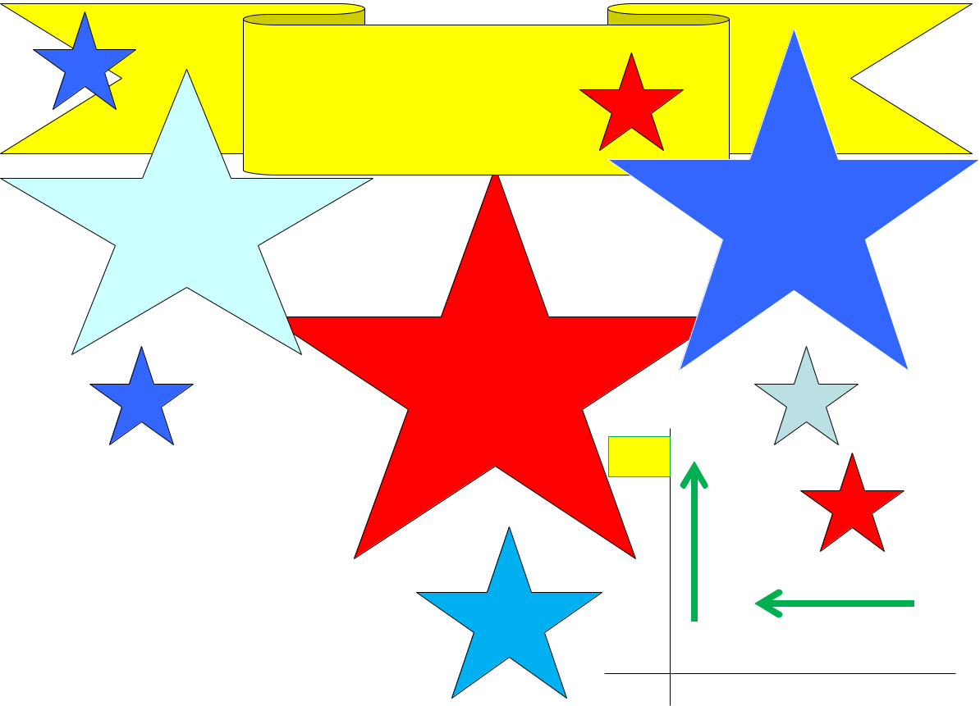

LIBERTY BELL GROUP 22nd BIRTHDAY

JULY 7, 2018

11 am To 3 pm
WHITE BANK PARK | Bring Family
 | and Friends
Colonial Heights
Pavilion #1
 | Hotdogs, Hamburgers, &
 | Drinks provided

 |  |  | Bring a covered
 |  |  |  | dish
 | Directions
From Fort Lee take |  | Temple Ave
towards South Park Mall. Turn R |  |  |  | Ask It
on Conduit Rd and follow all the way
 |  |  |  | Basket
down almost to end. Turn L on White
Bank Rd - in front of Tussing Elem
School

WB

RdConduit

Temple Ave (VA 144)

South Park Mall

